Luis Morales
CSCI 4321 - Computer Security
August 27, 2025
Lab 01 – Zenmap

This first image includes a terminal window showing the user is not the default administrator ‘Kali’, along with the first command sent to Zenmap.
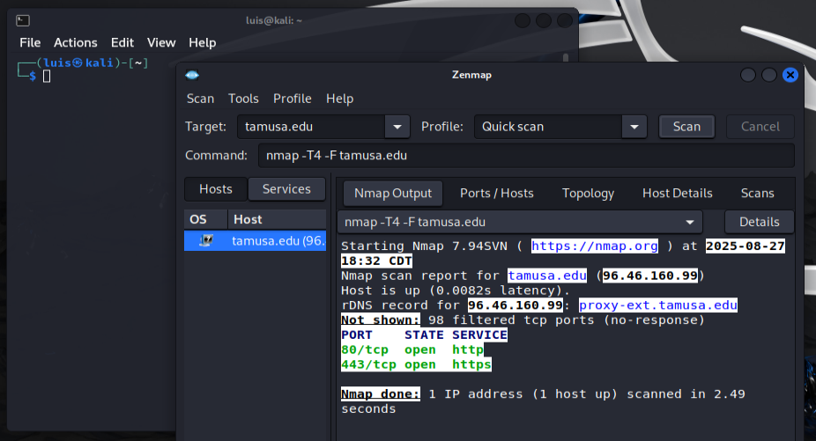
The quick scan was used on tamusa.edu and returned responses from 2 ports:
80 – used for http
443 – used for https

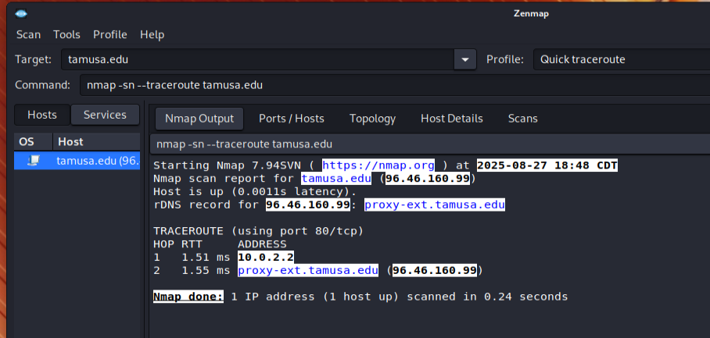
Using quick traceroute zenmap found one hop (10.0.2.2 – local host) to reach tamusa.edu
Using zenmap to do an intense scan of tamusa.edu resulted in a lot more information about the individual ports
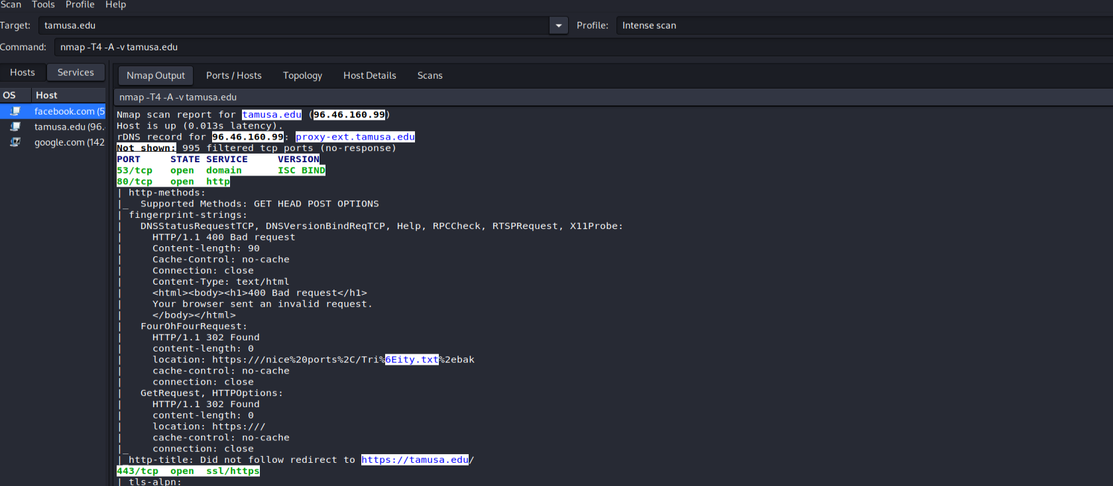
A quick scan of google.com returned the same open ports
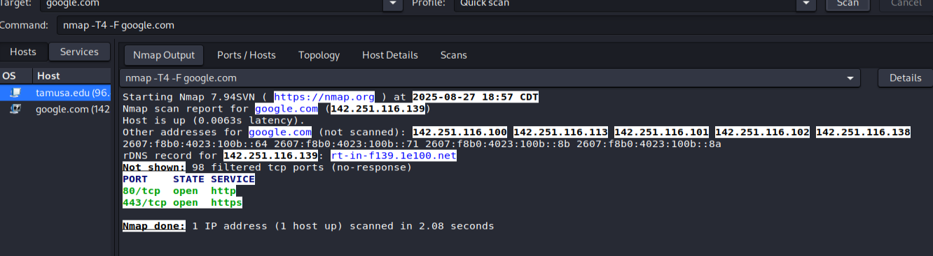
I did a quick scan on tamusa.edu using a vpn and here are my results
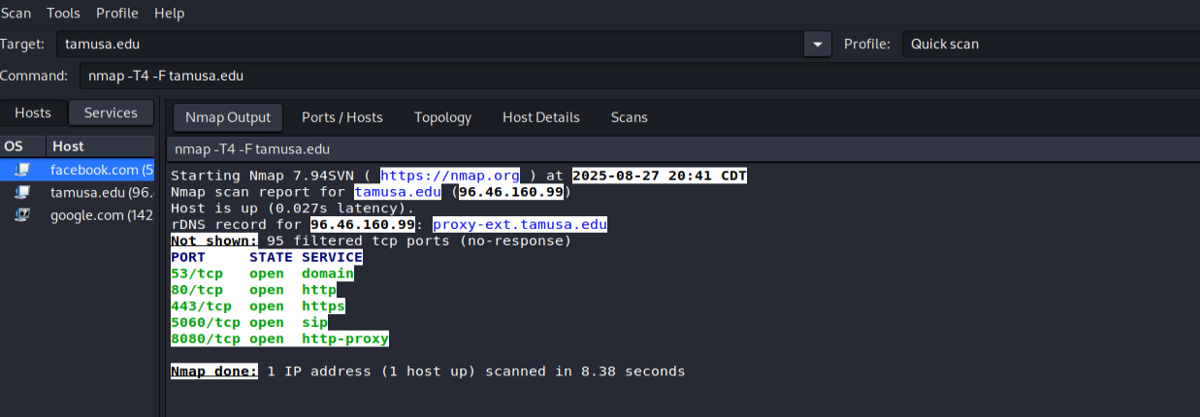
When the quick scan was done without the vpn only 2 ports were found open, but behind the vpn zenmap was able to discover 5 ports open
53 – DNS services
80 - http
443 - https
5000 - a common and often overlooked port, it's frequently used by developers for custom applications but can also be a security risk if not properly secured
8080 – an http alternative port

